At Offmore Primary School, we believe that every child can become a competent mathematician and every member of staff will provide the means to reach this status. We deliver a Maths curriculum which inspires and motivates children to love Maths and enable them to fulfil their personal ambitions and career goals in an ever-changing world, where they can contribute positively to society in their future.


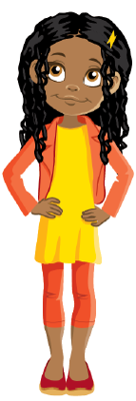
Practical Ideas
- Create puzzles where children match pairs of numbers that add up to 20. For example, have one piece with "7" and another with "13" and have them fit together.
- Create bingo cards with sums of 20. Call out a number, and children must find the complement on their cards to make 20.
- Use stacking blocks or LEGO bricks. Have children build towers with two colours, where the total number of blocks equals 20.
- Play card games like "Memory" or "Concentration" where children flip cards to find pairs that add up to 20.
- Create a large number line on the floor. Have children jump along the line in increments of 50 or 100, counting aloud with each jump.
- Use play money or real coins. Have children count by 50s using 50-pence pieces or by 100s using pound coins.
- Incorporate physical activities like star jumps or clapping to count by 50s and 100s. Each movement represents a number in the sequence.
During Autumn 1, the Year 3 children will be focusing on number bonds (+ and -) to 20 and counting in 50s and 100s. This will complement their work on numbers to 1,00 in their Maths lessons this term. Please take a look below at some different activities you could do with your child to help them to learn and remember these facts.
Know number bonds for all numbers up to 20.
Count in 50s and 100s.
Top tip: Little and often is the key! Can you do some of these whilst walking to school or on a car journey?
Key Vocabulary

count bonds hundreds fifties
Key Instant Recall Facts consist of knowledge that the children should know without having to think about it. Once they know these facts off by heart, they will be able to access other areas of Maths with ease.
Each half term, you will receive a newsletter containing the KIRFs that your child’s year group are focusing on and some ideas for how to practise these in fun, engaging and memorable ways.
In order to do this, we are giving the children every opportunity to build up their fluency in specific areas of Maths which will enable them to be successful mathematicians throughout their school career and beyond.

