At Offmore Primary School, we believe that every child can become a competent mathematician and every member of staff will provide the means to reach this status. We deliver a Maths curriculum which inspires and motivates children to love Maths and enable them to fulfil their personal ambitions and career goals in an ever-changing world, where they can contribute positively to society in their future.

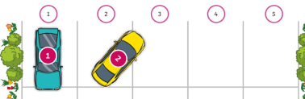

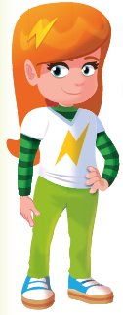
Practical Ideas
Have number cards or use toys with numbers written on and practise recognition of numerals.
Label toy cars with numbers and park them in the right spot on a paper carpark:

Have two groups of toys/snacks/pencils, lay them out in a line and count how
many in each line, which one is less than/more than/least/most?
Play Bunny Ears – hold up your hands on your head, with a given amount of finger, ask your child to make their own bunny ears with less or more fingers – ask them “how many am I holding up? How many are you holding up? Who has more? Who has less?
Have number cards to 10 and lay them out in order. Take one or 2 cards away and ask your child what’s missing, where should it go? What is more than this number? What is less?

During Autumn 1, the Reception children will be focusing on comparing numbers to 10, knowing their order. Please take a look below at some different activities you could do with your child to help them to remember these facts.
Name numbers in order to 10 and compare 2 numbers by saying which is more or less.
Top tip: Little and often is the key! Can you do some of these whilst walking to school or on a car journey?
Key Vocabulary
order compare one two three four
five six seven eight nine ten
more than less than

Key Instant Recall Facts consist of knowledge that the children should know without having to think about it. Once they know these facts off by heart, they will be able to access other areas of Maths with ease.
Each half term, you will receive a newsletter containing the KIRFs that your child’s year group are focusing on and some ideas for how to practise these in fun, engaging and memorable ways.
In order to do this, we are giving the children every opportunity to build up their fluency in specific areas of Maths which will enable them to be successful mathematicians throughout their school career and beyond.

